

Request for Expressions of Interest

Lot 1 Forrest Street Boyup Brook

HOUSING DEVELOPMENT

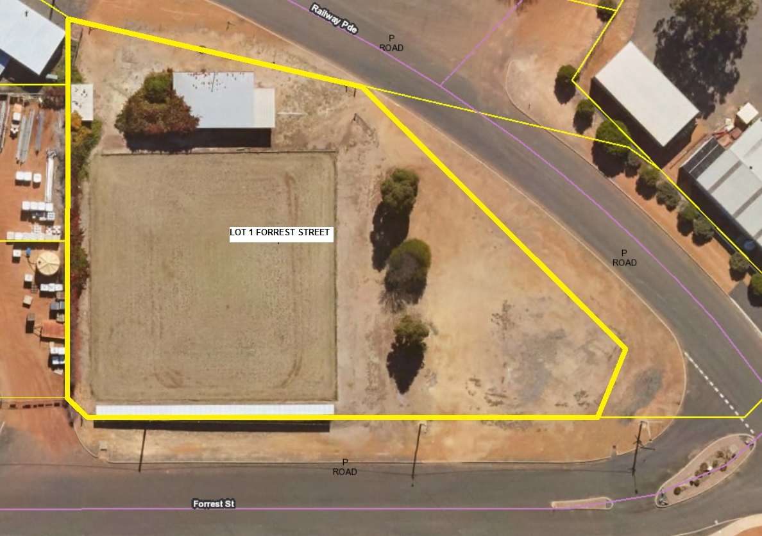

Issue Date: May 2020
Submission Deadline: 6 July 2020
Request To: Architects and Builders

TABLE OF CONTENTS

A. INTRODUCTION 3

B. THE OPPORTUNITY 4

D. SUBMISSION REQUIREMENTS 7

ATTACHMENT 1 – FEATURE SURVEY 8

ATTACHMENT 2 – EXPRESSION OF INTEREST FORM 9

REQUEST FOR EXPRESSIONS OF INTEREST (EOI)

A. INTRODUCTION

The purpose of this Expression of Interest is to lead to a design and construct contract initially for two dwellings with the successful bidder having the right to complete the balance of six buildings within the next 3-year period at the same price. This will be a two-phase process. Firstly, the EOI stage which will result in the successful bidder entering as A S4000 Design and Construct Contract.

The goals are to solicit meaningful responses from relevant proponents to:

- Provide a design for 8 dwellings at Lot 1 Forrest Street and a remote Septic Tank Effluent Disposal on adjoining land community scheme (to service the 8 dwellings) at a location yet to be confirmed; and

- Develop 8 dwellings within two stages:

Stage 1
- Site Works;
- Develop 1 X 2bdr/1bthr brick dwelling; (or brick veneer) of approximate 95 – 105m2
- Develop 1 X 3bdr/2bthr brick dwelling; and (or brick veneer) of approximate 135 – 145m2

Stage 2
- Develop 6 dwellings (design - subject to demand); and
- Incidentals (e.g. landscaping, fencing etc.)
- Develop Septic Tank Effluent Disposal system on adjoining land.

Expression of interest is sought from builders and or architects.
It is proposed that expressions of interest are presented to the Shire of Boyup Brook Council for consideration.

Issue Date: 28 May 2020
Submission Deadline: 6 July 2020
Works to commence: 20 July 2020
Completion: To be negotiated (Council is seeking 6 months build time)

B. THE OPPORTUNITY

- Who benefits from this project?
- The Shire of Boyup Brook, the general community and the designer/developer.
- Who is eligible to be involved in this project?
- Builders, designers, architects.
- What is being offered?
- Ultimately, a contract to build two-eight dwellings at Lot 1 Forrest Street, a Septic Tank Effluent System and incidentals (e.g. landscaping, fencing etc.)
- What is unique about this project?
- Consider accommodating aged persons and/or holiday persons.
- Consider potential for a Septic Tank Effluent Disposal system to service 8 dwellings to locate the effluent system off-site.
- Why does this project matter?
- The Shire of Boyup Brook is in need of accommodation to service holiday makers, workers and aged persons.

C. ABOUT THE PROJECT

The subject Lot was previously developed with a bowling green and has since been rezoned from ‘Parks and Recreation’ to ‘Residential’ R15/30.

The subject Lot is zoned Residential R15/30. Where a Lot has dual density coding R15/30, the local government may approve residential development at a higher code where development is connected to a Septic Tank Effluent Disposal System. The R-Codes supports an average of one dwelling for every 666m² at the R15 density and an average of one dwelling for every 300m² at the R30 density. The subject Lot is 3758m² in area meaning a potential for 5 dwellings at the R15 density and 12 dwellings at the R30 density. The Shire believes that 8 dwellings can comfortably fit on the subject Lot, meaning a design and development needs to incorporate an off-river Septic Tank Effluent Disposal System.

Clearly the intent is to develop the subject land for residential purposes to cater for demand for holiday accommodation, workers accommodation and/or aged accommodation.

The design/development is to consider the overall capacity for 8 dwellings on the subject Lot and the following:

- Streetscape;  - Access;  - Car parking;  - Solar Passive design;  - Surveillance measures;  - Design for aged persons;  - Site works; | - Private Open Space;  - Landscaping;  - Fencing;  - Earthworks;  - Retaining;  - Servicing (effluent disposal, power, water).
SELECTION CRITERIA WILL BE BASED

- Design Concepts;
- Integrated appearance to match town character;
- Value for money;
- Local content;
- Financial stability of the applicant;
- Previous experience in similar works;
- Time to complete.

STAGING
It is proposed that the development is completed in two stages. The first stage is the construction of two dwellings. The second stage is the construction of 6 dwellings and incidentals (e.g. landscaping, fencing and a Septic Tank Effluent Disposal System etc.)
The following characteristics apply to the subject land:

- Lot 1 Forrest Street amounts to 3785m2;
- Lot 1 Forrest Street is 191m above the AHD;
- A disused shed and shade structure remain on-site at Lot 1 Forrest Street;
- An overhead powerline runs along the southern boundary of Lot 1 Forrest Street;
- An underground reticulated water pipe runs along the western boundary of Lot 1 Forrest St;
- Lot 1 Forrest Street is triangular in shape with roads on two sides and a farm sales equipment store located on the third side (west);
- Lot 1 Forrest Street is cleared of native vegetation (three singular trees remain);
- Surface water discharges to the east;
- The site is not classified as a contaminated site;
- The soil is a sandy loam/clay;
- Vehicle access is via Forrest Street and Railway Parade. Both these roads lead to the centre of town. There are no footpaths adjoining the site;
- The site is connected to the Shires stormwater (drainage) network located within the road network;
- The site is connected to the reticulated water system operated by the Water Corporation;
- There is currently no reticulated sewerage in Boyup Brook. Septic tanks with leach drains are the predominant method of effluent disposal;
- Overhead power and telephone services are connected to the site;
- The subject land is outside of a floodplain area recorded by the Department of Water;
- Portion of the subject site is within 100m of bushfire-prone vegetation located to the south east;

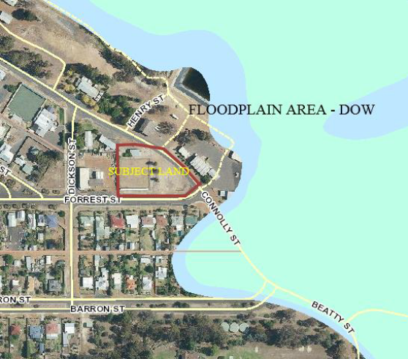 | 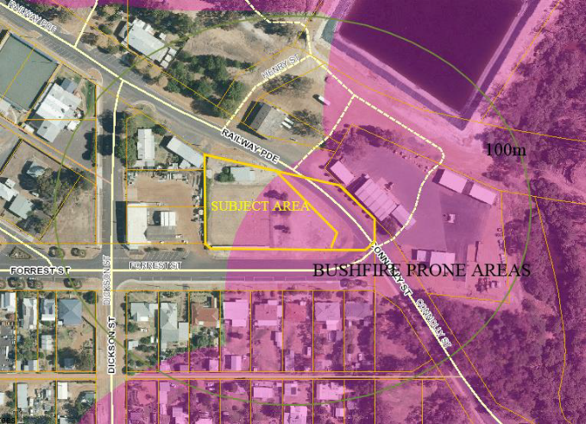

D. SUBMISSION REQUIREMENTS

Prior to preparing the Expression of Interest, respondents are encouraged to check their eligibility/capability to deliver on designing and developing dwellings (i.e. registered builder).

The Shire of Boyup Brook is willing to hold a compulsory information session to provide details about the opportunity that may not be explicit in this EOI document and to answer questions and provide further information about the project.

For any queries, please contact Daly Winter at email address: cerm@boyupbrook.wa.gov.au

If interested in expressing interest in the project, please fill out the Expression of Interest Form (see attachment 2) and include the following information:

- A description of why the project is of interest to the individual or company;
- Licencing particulars;
- A brief history of the organisation including years of operation;
- What is the organisation’s experience working on a similar project?
- How is the organisation service(s) or practice(s) relevant to the project?
- Cost

Please email submissions to ea@boyupbrook.wa.gov.au by the 6th July 2020.

It is proposed that expressions of interest are presented to the Shire Council with a recommendation to engage a candidate to design and construct the project.

The last stage of this proposal is the award of an A S4000 Design and Construct Contract to build two units.

ATTACHMENT 1 – FEATURE SURVEY
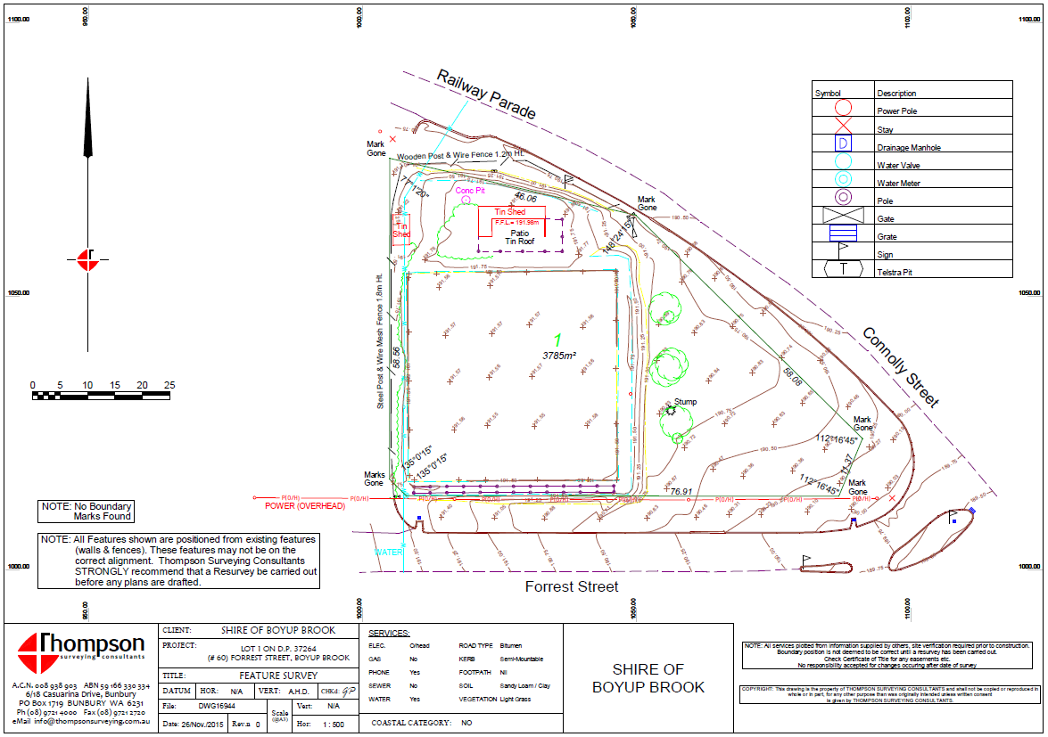

ATTACHMENT 2 – EXPRESSION OF INTEREST FORM

Company name |  | Postal address
Contact person |  | ACN
Address |  | Telephone
Suburb |  | Mobile
State |  | Email
Post code

Builders licence number
Date when business commenced operation
Evidence of legal entity attached
Date of company registration
A copy of registration documents must be submitted on initial registration if name changes occurs.
State trading name

Business structure
Names and address of all members of business
State trading names

Have you, or any business you have been managing, ever failed to complete a construction contract? | Yes: ☐ No: ☐
Have you, or any business you have been managing, been declared bankrupt or been subject to repossession proceedings over the past seven years? | Yes: ☐ No: ☐
Are there any judgement debts or court orders against the respondent? | Yes: ☐ No: ☐

I/We hereby submit the expression of interest with the Shire of Boyup Brook and declare that to the best of my/our knowledge the particulars shown herein are true and correct

Date:

Signed

Name:

ADDENDUM 1

- Notification that Council will consider non-conforming bids for lightweight structures and transportable modules.
- Notes regarding Attachment 2 – Clarification on information required.

Council will consider non-conforming bids

As part of this Expression of Interest process, Council will consider non-conforming bids for lightweight structures and transportable modules.

ATTACHMENT 2 – EXPRESSION OF INTEREST FORM

Company name |  | Postal address
Contact person |  | ACN
Address |  | Telephone
Suburb |  | Mobile
State |  | Email
Post code

Builders licence number
Date when business commenced operation
Evidence of legal entity attached | [Is ASIC extract sufficient?] Yes an ASIC extract is sufficient.
Date of company registration | [Company registration or building registration?] Both are required in WA.
A copy of registration documents must be submitted on initial registration if name changes occurs. | [Please confirm what you are seeking?] Evidence of current registration.
State trading name | If you are a Company trading as… E.g Jack Industries Pty Ltd T/As Jack Building Company.

Business structure
Names and address of all members of business | [Is ASIC extract sufficient?] Yes
State trading names | [Please confirm how this differs to same question above?] Does the Company trade under other names? If so, please state other trading names.

Have you, or any business you have been managing, ever failed to complete a construction contract? | Yes: ☐ No: ☐
Have you, or any business you have been managing, been declared bankrupt or been subject to repossession proceedings over the past seven years? | Yes: ☐ No: ☐
Are there any judgement debts or court orders against the respondent? | Yes: ☐ No: ☐

I/We hereby submit the expression of interest with the Shire of Boyup Brook and declare that to the best of my/our knowledge the particulars shown herein are true and correct
Date:

Signed

Name:

