



SHIRE OF BOYUP BROOK

TENDER REGISTER

Document Control
Date Reviewed | Details/Action | Author
30 May 2025 | Original Version | Magdalena Le Grange
15 August 2025 | Reviewed and updated | Magdalena Le Grange
19 December 2025 | Updated | Magdalena Le Grange

Contents
RFT 25/001 – Evacuation Centre and Sporting Hub Upgrade 4
RFT 24/004 – Bridge Inspections and Maintenance Services 6
RFT 24/003 – Roads Maintenance, Upgrade and Build Services 8
RFT 24/002 – Design and Construct Sandakan Park Playground 10
RFT 24/001 – Cemetery Upgrade 12
RFT 23/003 – Supply and delivery of one (1) New Four-Wheel Drive Front End Loader 14
RFT 23/002 – Supply and delivery of a Diesel Motor Grader 16
RFT 23/001 – Town Hall Precinct Building Upgrades 18
RFT 20/004 – Supply of Wet Hire Plant and Equipment 20
RFT 20/003 – Supply full Service Bitumen and Sprayed Bituminous surfacing 22
RFT 20/002 – Provision of waste management and Bulk waste transfer 24
RFT 20/001 – Supply of Rural Road Verge Clearing and Pruning Services 25



RFT 25/001 – Evacuation Centre and Sporting Hub Upgrade
_________________________________________________________________________

Tender Details
Tender Number | RFT 25/001
Tender Title | Evacuation Centre and Sporting Hub Upgrade
Description of the goods/services required | The Shire of Boyup Brook is seeking to engage a suitably experienced contractor to upgrade its Evacuation Centre/Sporting Hub complex
Advertisement Details | The West Australian, Saturday 16 August 2025
Tender closing date and time | Tuesday 7 October 2025 at 3:00pm AWST

Tenders Received From
1. | 3Build
2. | Atlas Building (WA)
3. | Barna Construction
4. | BRC Building Solutions Pty Ltd
5. | Devlyn Construction

Outcome
Date of Council Resolution | 27 November 2025
Agenda Item No | 9.1.1
Name of Successful Tenderer | Barna Construction Pty Ltd
Contract Date | 22 December 2025
Contract Value | As per Tender Submission

Advertisement

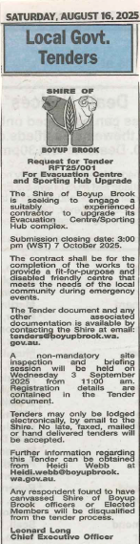
___________________________________________________________________
End

RFT 24/004 – Bridge Inspections and Maintenance Services
_________________________________________________________________________

Tender Details
Tender Number | RFT 24/004
Tender Title | Bridge Inspections and Maintenance Services
Description of the goods/services required | Provide bridge maintenance and inspection services within the Shire’s boundaries
Advertisement Details | The West Australian, Saturday 31 August 2024
Tender closing date and time | Monday 16 September 2024 at 3:00pm AWST

Tenders Received From
1. | Rhythm Civil
2. | Timber Insight
3. | Downer EDI Works Pty Ltd (withdrawn offer 2/10/2024)

Outcome
Date of Council Resolution
Agenda Item No
Name of Successful Tenderer | Tender not awarded, converted to Quotation being under $250,000
Contract Date
Contract Value

Advertisement

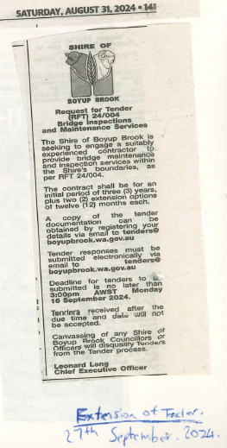

Tender Amendment
Tender Extended closing date and time | Friday 27 September 2024 at 3:00pm AWST

___________________________________________________________________
End

RFT 24/003 – Roads Maintenance, Upgrade and Build Services
_________________________________________________________________________

Tender Details
Tender Number | RFT 24/003
Tender Title | Roads Maintenance, Upgrade and Build Services
Description of the goods/services required | Provide roads Maintenance, Upgrade and Build Services
Advertisement Details | The West Australian, Saturday 27 July 2024
Tender closing date and time | Friday 30 August 2024 at 3:00pm AWST

Tenders Received From
1. | Blackwood Plant Hire
2. | Wilgee Civil
3. | Dronow
4. | Kloppers
5. | WCP

Outcome
Date of Council Resolution | 19 December 2024
Agenda Item No | 9.1.1
Name of Successful Tenderer | Panel tender: Blackwood Plant Hire, Wilgee Civil, Dronow, Kloppers & WCP
Contract Date
Contract Value

Advertisement

___________________________________________________________________
End

RFT 24/002 – Design and Construct Sandakan Park Playground
_________________________________________________________________________

Tender Details
Tender Number | RFT 24/003
Tender Title | Design and Construct – Sandakan Park Playground
Description of the goods/services required | The Shire of Boyup Brook seeks an experienced Lead Project Contractor to undertake:  • The design and construction of the new Sandakan Park Playground.  • The full documentation control and construction management; and  • The full construction and delivery of the works for the development of the Sandakan Park Playground.
Advertisement Details | The West Australian, Saturday 6 July 2024
Tender closing date and time | Friday 9 August 2024 at 3:00pm AWST

Tenders Received From
1. | CRS Creative
2. | Phase 3 Landscape Constructions Pty Ltd
3. | LD Total
4. | Active Discovery
5. | Nature Playgrounds

Outcome
Date of Council Resolution | 29 August 2024
Agenda Item No | 9.3.11
Name of Successful Tenderer | Active Discovery
Contract Date
Contract Value | $1,591,608 (excl GST)

Advertisement

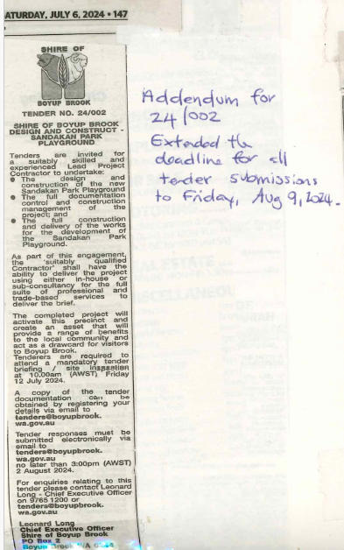

Tender Amendment
Tender Extended closing date and time | Friday 9 August 2024

___________________________________________________________________
End

RFT 24/001 – Cemetery Upgrade
_________________________________________________________________________

Tender Details
Tender Number | RFT 24/001
Tender Title | Cemetery Upgrade
Description of the goods/services required | The project includes the following works:  - Drainage upgrades  - Carpark construction  - Minor roadworks.
Advertisement Details | The West Australian, Friday 1 March 2024
Tender closing date and time | Friday 22 March 2024 at 4:00pm AWST

Tenders Received From
1. | DCL Formwork Pty Ltd
2. | Wilgee Civil

Outcome
Date of Council Resolution
Agenda Item No
Name of Successful Tenderer | Tender not awarded, converted to Quotation being under $250,000
Contract Date
Contract Value | $248,469

Advertisement

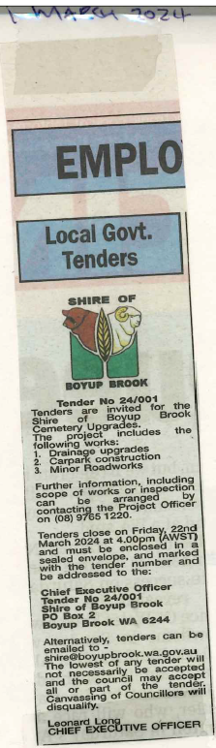

Tender Amendment
Advertisement Details | The West Australian, Saturday 23 March 2024
Tender Extended closing date and time | Friday 5 April 2024 at 4:00pm AWST

___________________________________________________________________
End

RFT 23/003 – Supply and delivery of one (1) New Four-Wheel Drive Front End Loader
_________________________________________________________________________

Tender Details
Tender Number | RFT 23/003
Tender Title | Supply and delivery of one (1) New Four-Wheel Drive Front End Loader
Description of the goods/services required | Supply and delivery of one (1) New Four-Wheel Drive Front End Loader
Advertisement Details | The West Australian, Monday 9 October 2023
Tender closing date and time | Friday 27 October 2023 at 2:00pm AWST

Tenders Received From
1. | Liebherr-Australia Pty Ltd
2. | Hitachi Construction Machinery
3. | JCB Construction Equipment
4. | Westrac
5. | Komatsu
6. | McIntosh & Son
7. | McIntosh & Son

Outcome
Date of Council Resolution | 14 December 2023
Agenda Item No | 9.1.1
Name of Successful Tenderer | Komatsu Australia Pty Ltd
Contract Date
Contract Value | $261,281 (excl GST)

Advertisement

___________________________________________________________________
End

RFT 23/002 – Supply and delivery of a Diesel Motor Grader
_________________________________________________________________________

Tender Details
Tender Number | RFT 23/002
Tender Title | Supply and delivery of a Diesel Motor Grader
Description of the goods/services required | Purchase Articulated Motor Grader 100-120KW
Advertisement Details | The West Australian, Monday 9 October 2023
Tender closing date and time | Tuesday 31 October 2023 at 2:00pm AWST

Tenders Received From
1. | McIntosh & Son
2. | McIntosh & Son
3. | Westrac
4. | Komatsu

Outcome
Date of Council Resolution | 14 December 2023
Agenda Item No | 9.1.2
Name of Successful Tenderer | Komatsu Australia Pty Ltd
Contract Date
Contract Value | $375,359 (excl GST)

Advertisement

___________________________________________________________________
End

RFT 23/001 – Town Hall Precinct Building Upgrades
_________________________________________________________________________

Tender Details
Tender Number | RFT 23/001
Tender Title | Town Hall Precinct Building Upgrades
Description of the goods/services required | The project includes the following works:  - Carpark and building drainage works  - Internal and external building repairs.
Advertisement Details | The West Australian, Tuesday 31 January 2023
Tender closing date and time | Tuesday 21 February 2023 at 4:00pm AWST

Tenders Received From
1. | BRC Building Solutions

Outcome
Date of Council Resolution | 2 March 2023
Agenda Item No | 5.1
Name of Successful Tenderer | BRC Building Solutions
Contract Date
Contract Value | $639,129.60 (excl GST)

Advertisement

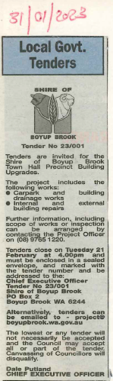

___________________________________________________________________
End

RFT 20/004 – Supply of Wet Hire Plant and Equipment
_________________________________________________________________________

Tender Details
Tender Number | RFT 20/004
Tender Title | Supply of wet hire plant and equipment
Description of the goods/services required | Engage the services of wet hire plant and equipment to assist with the Shire’s works program and services to ensure the safety of our road users
Advertisement Details | Advertised on WALGA eQuotes Portal, 27 November 2020
Tender closing date and time | Friday 11 December 2020 at 5:00pm AWST

Tenders Received From
1. | Blackwood Plant Hire
2. | EarthMac Pty Ltd

Outcome
Date of Council Resolution | 14 January 2021
Agenda Item No | 3.2
Name of Successful Tenderer | Blackwood Plant Hire
Contract Date
Contract Value

Advertisement

___________________________________________________________________
End

RFT 20/003 – Supply full Service Bitumen and Sprayed Bituminous surfacing
_________________________________________________________________________

Tender Details
Tender Number | RFT 20/003
Tender Title | Supply full Service Bitumen and Sprayed Bituminous surfacing
Description of the goods/services required | Supply full Service Bitumen and Sprayed Bituminous surfacing
Advertisement Details | Advertised on WALGA eQuotes Portal
Tender closing date and time | Friday 11 December 2020 at 5:00pm AWST

Tenders Received From
1. | Downer EDI Works Pty Ltd
2.

Outcome
Date of Council Resolution
Agenda Item No
Name of Successful Tenderer | Downer EDI Works Pty Ltd
Contract Date
Contract Value

Advertisement

___________________________________________________________________
End

RFT 20/002 – Provision of waste management and Bulk waste transfer
_________________________________________________________________________

Tender Details
Tender Number | RFT 20/002
Tender Title | Provision of waste management and Bulk waste transfer
Description of the goods/services required | Provision of waste management and Bulk waste transfer
Advertisement Details | Advertised on WALGA eQuotes Portal on Tuesday 1 September 2020
Tender closing date and time | Tuesday 29 September 2020 at 2:30pm AWST

Tenders Received From
1. | Hastie Waste Pty Ltd

Outcome
Date of Council Resolution | 29 October 2020
Agenda Item No | 10.1.1
Name of Successful Tenderer | Tender not awarded
Contract Date
Contract Value

Advertisement

___________________________________________________________________
End

RFT 20/001 – Supply of Rural Road Verge Clearing and Pruning Services
_________________________________________________________________________

Tender Details
Tender Number | RFT 20/001
Tender Title | Supply of Rural Road Verge Clearing and Pruning Services
Description of the goods/services required | Supply of Rural Road Cleaning and pruning services
Advertisement Details | Advertised on WALGA eQuotes Portal on Tuesday 1 September 2020
Tender closing date and time | Tuesday 29 September 2020 at 2:30pm AWST

Tenders Received From
1. | Twinkarri Pty Ltd
2. | Thomas Contracting Services Pty Ltd

Outcome
Date of Council Resolution | 29 October 2020
Agenda Item No | 10.1.1
Name of Successful Tenderer | Twinkarri Pty Ltd
Contract Date
Contract Value | $3,420 day rate

Advertisement

___________________________________________________________________
End

