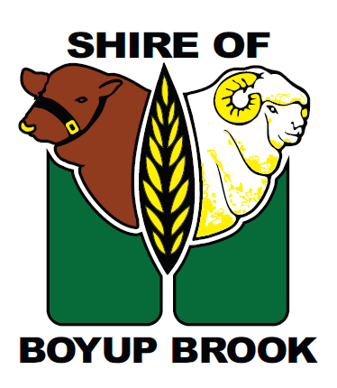

PUBLIC NOTICE

LIMIT OF WATER SUPPLY OVER THE WEEKEND

Water Corporation is again asking residents to limit water supply today and over the weekend while we resolve issues caused by the bushfire at Hester Dam. Water Corporation is currently carting water from Collie to supply Boyup Brook, however we are experiencing issues in maintaining water pressure.

Shire of Boyup Brook

18 February 2022

