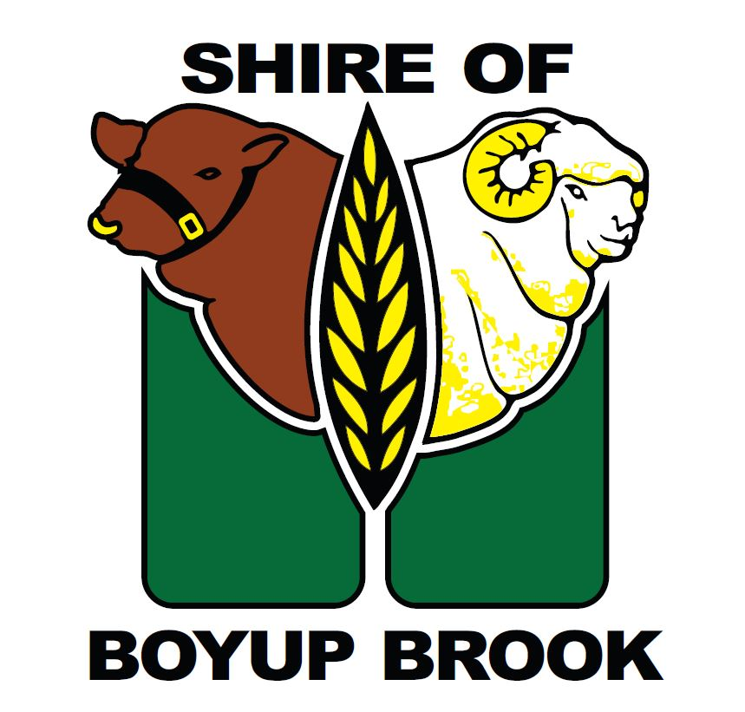
Media Release

Council Endorses Revised Operational Model for Rylington Park

At its Ordinary Council Meeting held on 26 February 2026, the Shire of Boyup Brook Council resolved to adopt a revised leasing-based operational model for Rylington Park.

The decision follows consideration of a recommendation from the Rylington Park Committee after review of a number of possible future operating models for the property. As part of the adopted approach, Council resolved to move toward leasing the farm component through an open market process, while retaining certain infrastructure under Shire control and preserving arrangements that continue to support community benefit and agricultural research outcomes. Council also resolved that proceeds from the sale of machinery, produce and livestock be quarantined in a reserve account to allow for the possible reinstatement of farming operations in the future, should a future Council determine that course is appropriate.

The resolution was made following assessment of the changing agricultural environment and the financial performance of the farm in recent years. In its report to Council, the key reasons for the change were identified as ensuring compliance with the Local Government Act 1995, providing long-term financial sustainability, reducing financial risk exposure to ratepayers, honouring the wishes of the late Mr Eric Farleigh, and maintaining provision for community benefit and agricultural research.

Council also noted that Edith Cowan University had been consulted during the process and was supportive of the proposed model, which will still allow ECU to undertake digital farming trials at Rylington Park.

The Shire acknowledges that Rylington Park is an important community asset with a unique history and purpose. For that reason, the Shire is currently seeking legal advice on the most appropriate method for calling for lease proposals, to ensure the process is undertaken properly, fairly and transparently.

Further information will be provided to the community as this process progresses.

Cr Helen O’Connell
Shire President

25 March 2026

